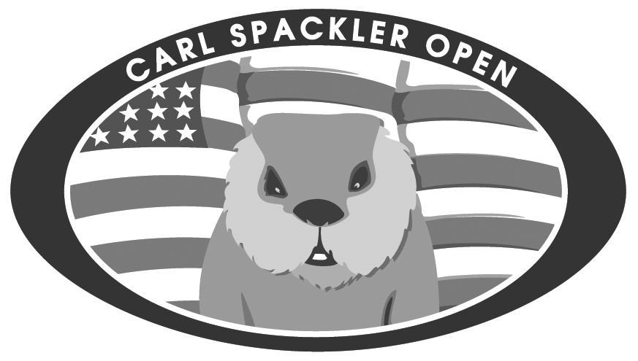 | Awards Presentation  PAGE 1 of 3

 | WINNER | NOTES  Need Points Scored, Distance, or Storyteller.
Carl Spackler Outfit
Last Place of the Carl Spackler Open.
Al Czverik Outfit
Last Place after Round 2.

 | WINNER | NOTES  Need Points Scored, Distance, or Storyteller.
ON COURSE CONTESTS
Closest to the Pin
• Round 1 HOLE:
• Round 1 HOLE:
• Round 2 HOLE:
• Round 2 HOLE:
• Round 3 HOLE:
• Round 3 HOLE:
Longest Putt
• Round 1 HOLE: 18
• Round 2 HOLE: 18
• Round 3 HOLE: 18

Awards Presentation
PAGE 2 of 3

 | WINNER | NOTES  Need Points Scored, Distance, or Storyteller.
ON COURSE CONTESTS
Longest Drive
• Round 1 HOLE:
• Round 1 HOLE:
• Round 2 HOLE:
• Round 2 HOLE:
• Round 3 HOLE:
• Round 3 HOLE:

 |  | WINNER | NOTES  Need Points Scored, Distance, or Storyteller.
The Noonan Award
Most Points by Rookie
Rookie of the Year
Captains Club Choice
Tara Boland Award
Pat Boland Choice
Stroke Glass
Most Putt Points
Dooty / Crapper Award
Least Putt Points Tournament
Webb Awards
Best Player in History
Awards Presentation
PAGE 3 of 3

 | WINNER | NOTES  Need Points Scored, Distance, or Storyteller.
Skills Challenge Contest
Winner of Skills Competition
4-man Scramble

 | WINNER | NOTES  Need Points Scored, Distance, or Storyteller.
Horses Ass Nominations
• Nomination #1
Captains Club Choice
• Nomination #2
Captains Club Choice
• Nomination #3
Captains Club Choice
• Award Winner
Captains Club Choice

 | WINNER | NOTES  Need Points Scored, Distance, or Storyteller.
TOP 5 LEADERBOARD
• 5th Place
• 4th Place
• 3rd Place
• 2nd Place
Jacket & Championship Trophy
1st place of Carl Spackler Open

