Gmail automatically identifies suspicious email and marks those emails as "spam" or "junk". When you open your Spam/Junk label or folder inside your email account, you'll see emails that were marked as Spam/Junk by you or Gmail. Each email will often include a label at the top that explains why it was sent to Spam/Junk. You can "mark" or "unmark" emails as Spam/Junk.

Participants of the Carl Spackler Open could experience an email account that does not receive important event communications. Participants who have not received emails during the registration period and/or participant option period from our Poststats server are expected to check their "Spam" and/or "Junk" folder.

This document includes a few screen shots below from a gmail account. It shows examples for gmail accounts. It visually attempts to show you where to mark an email as "NOT SPAM" or "NOT JUNK". This type of action likely will send future emails directly to your inbox.

This is a 4-page document.

GMAIL WEBSITE USING MICROSOFT WINDOWS
The email screenshot is taken inside the Spam folder (circled in green). Clicking "Not Spam" (circled in red) will move the email and also mark future emails appropriately.

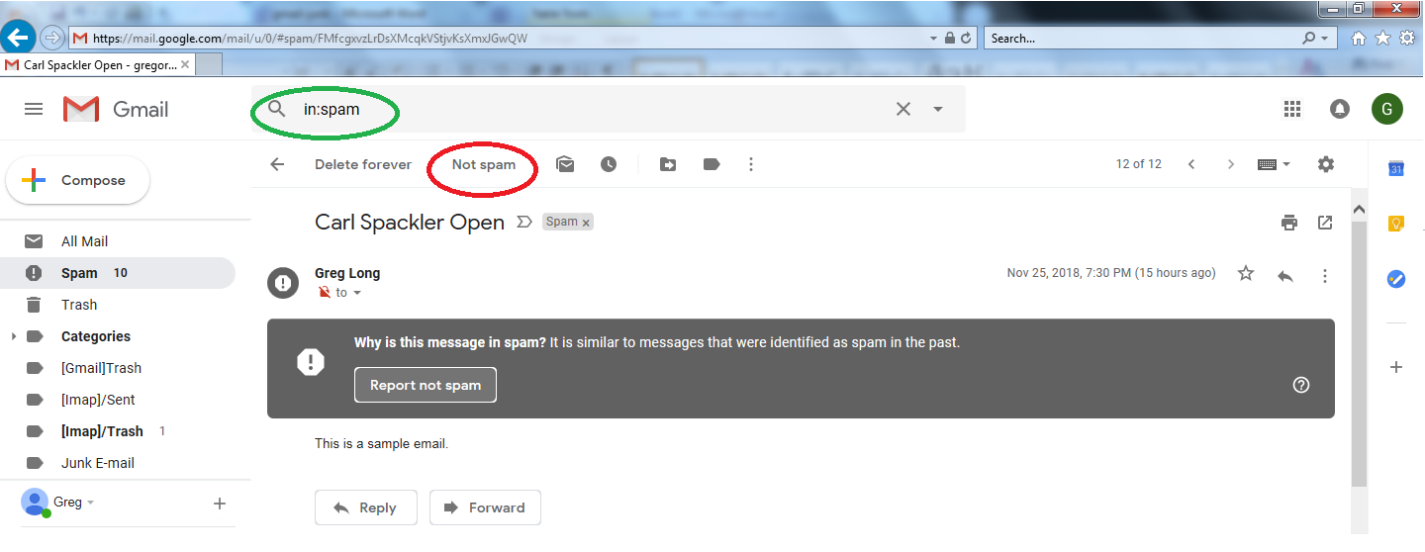

GMAIL WEBSITE USING APPLE IPAD
The email screenshot is taken inside the Spam folder (circled in green). Clicking "Not Spam" (circled in red) will move the email and also mark future emails appropriately.

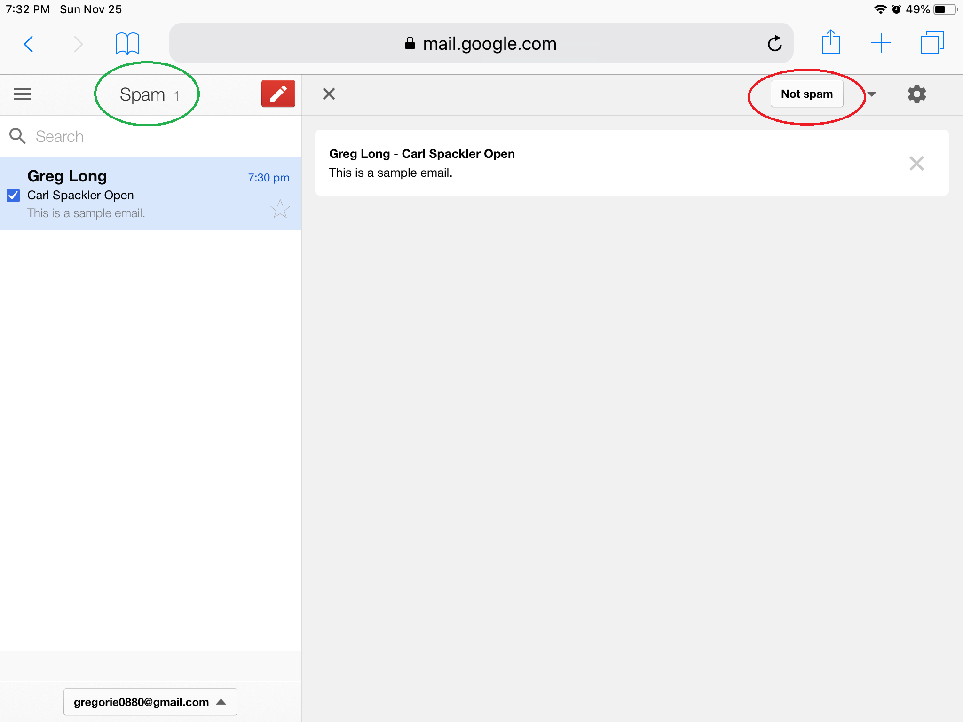

EMAIL APP FOR GMAIL USING APPLE IPAD
The email screenshot is taken inside the Junk folder (circled in green). Clicking the flag (circled in red) and then "Mark as Not Junk" (circled in red) will move the email and also mark future emails appropriately.

